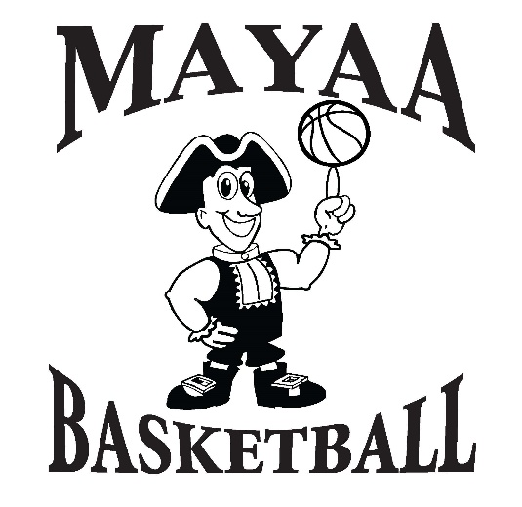

The MAYAA Rock-in The Rim tournament is for 5th & 6th grade school teams. It will be a double elimination tournament the dates are the 9th and 10th and 11th of March. We run this like an AAU tournament. There is no cost to the teams. The charge at the door for spectators will be $3.00 per day and we will have t-shirts and food at our concession stand to raise money for our league. We have prizes for all the kids, we hope to see you there please come support the MAYAA Basketball program.

